## **Migrate Unsupported ASR Linux Vms To Azure –Step By Step.**

Preface:

This guide is a step by step walkthrough on how to migrate AWS instances to azure.

Before starting with this guide check if your vm is supported move, using the ASR

Please use the following link:

<https://docs.microsoft.com/en-us/azure/site-recovery/site-recovery-migrate-aws-to-azure>

Once verified your vm is not supported for ASR, please use this guide to migrate:

This guide assumes you have only one disk.

For multiple disks ,disable fstab for this disks and move os than add the data disks.

Perquisites:

On AWS side:

* Login to each vm and install the following :
* Install LIS integration tools : <https://www.microsoft.com/en-us/download/details.aspx?id=46842> for Ubuntu <http://www.linux-magazine.com/Issues/2014/158/Linux-Integration-Services>
* Install Azure agent : <https://github.com/Azure/WALinuxAgent>
* Reboot the vm and check connectivity.
* Make sure Selinux is disabled on the vm,
* Create Sudo user for migration (migrate)
* Shut down the vm.

Your vm is ready for migration.

On AZURE side:

* Create a new linux vm instance that will be with the same number of disks equal to the number of vms you want to migrate.
* Don’t partition the disk just attached them to the vm.

THE STEPS TO COPY VM FROM AWS TO AZURE.

* You will need to terminate the vm but keep the volumes
* Attach the above volume to your new host vm.
* SSh to the new vm
* Make sure you see the volume there use lsblk :

NAME MAJ:MIN RM SIZE RO TYPE MOUNTPOINT

xvda 202:0 0 8G 0 disk

`-xvda1 202:1 0 8G 0 part /

xvdf 202:80 0 8G 0 disk

`-xvdf1 202:81 0 8G 0 part

here you can see the two volumes :

xvda the current one

xvdf the migrated one

* Generate new private/public key using ssh-keygen

Copy the public key to a vm in azure and use the reset password to place the public key there :

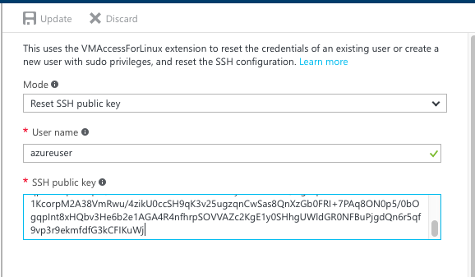

wait for it to be saved.

-verify by logging to this vm from the new instance on Aws.

-on the destination vm make sure you have enough space for the os to be copied.

-on the source run the following command:

dd if=/dev/xvdf | gzip -c --fast | ssh user@ip 'dd of=/home/user/xvdf.img.gz'

wait for the copy to finish –this can take a while.

Once done you should see the following output :

**root@ip-172-31-30-13**:**/root/.ssh**# dd if=/dev/xvdf | gzip -c --fast | ssh azureuser@52.178.176.248 'dd of=/home/azureuser/xvdf.img.gz'

16777216+0 records in

16777216+0 records out

8589934592 bytes (8.6 GB, 8.0 GiB) copied, 141.191 s, 60.8 MB/s

906779+1 records in

906779+1 records out

464271094 bytes (464 MB, 443 MiB) copied, 140.636 s, 3.3 MB/s

-Login to the azure vm from aws and verify the file is there

On the Azure VM follow these steps :

Type lsscsi to make sure the extra disk is there :

**root@k8s-master-5A4B675-0**:**~**# lsscsi

[1:0:0:0] cd/dvd Msft Virtual CD/ROM 1.0 /dev/sr0

[2:0:0:0] disk Msft Virtual Disk 1.0 /dev/sda

[3:0:1:0] disk Msft Virtual Disk 1.0 /dev/sdb

[5:0:0:0] disk Msft Virtual Disk 1.0 /dev/sdc -🡪Extra disk

Run the following command :

dd if=/home/azureuser/xvdf.img.gz | gunzip -1 - | dd of=/dev/sdc

this could take a while –please wait for it ….

Once done you should see this message :

906779+1 records in

906779+1 records out

464271094 bytes (464 MB, 443 MiB) copied, 5176.3 s, 89.7 kB/s

16777216+0 records in

16777216+0 records out

8589934592 bytes (8.6 GB, 8.0 GiB) copied, 5188.72 s, 1.7 MB/s

next validate that you have the same partition on this disk :

**root@k8s-master-5A4B675-0**:**~**# fdisk /dev/sdc

Welcome to fdisk (util-linux 2.27.1).

Changes will remain in memory only, until you decide to write them.

Be careful before using the write command.

Command (m for help): p

**Disk /dev/sdc: 60 GiB, 64424509440 bytes, 125829120 sectors**

Units: sectors of 1 * 512 = 512 bytes

Sector size (logical/physical): 512 bytes / 512 bytes

I/O size (minimum/optimal): 512 bytes / 512 bytes

Disklabel type: dos

Disk identifier: 0x00000000

**Device** **Boot** **Start**  **End**  **Sectors** **Size** **Id** **Type**

/dev/sdc1 * 16065 16777182 16761118 8G 83 Linux

now you can detach the disk from the vm and create the vm from this disk.

Use this sample template to create the vm from the disk :

<https://github.com/digeler/migrate-AWS>

once done you can log to the vm :

using :

ssh -i "mac.pem" ubuntu@[your azure public ip]

remove the floppy :

sudo rmmod floppy

**root@ip-172-31-26-10**:**/var/log**# echo "blacklist floppy" | sudo tee /etc/modprobe.d/blacklist-floppy.conf